Are you using the same smart device for more than One participant?
If you are using the same smart device please follow these steps. Once you have opened the link for the first participant the session is saved meaning that the webpage will not randomise each Method of MFA.
If you are using Chrome on Mac (Apple) or Windows
- Open Google Chrome
- Select the three-dot icon in the upper right corner
Apple – Incognito Window
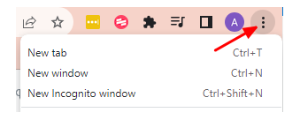
Windows – Incognito Window
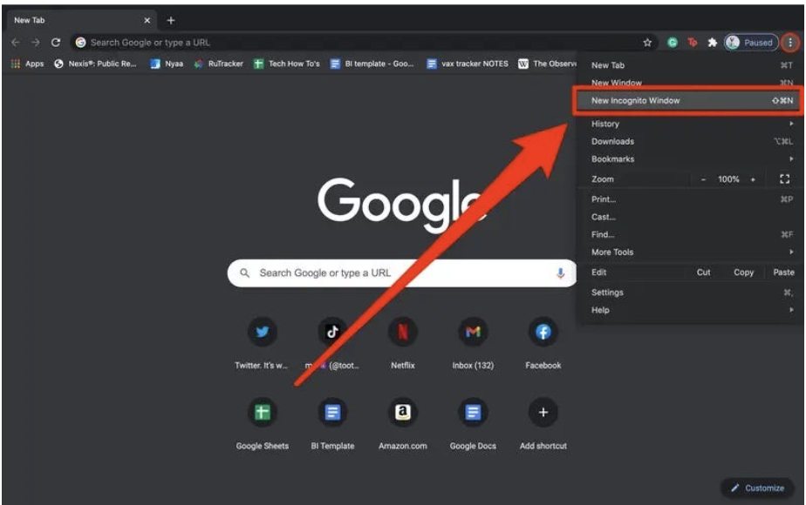

If you are using Firefox – New Private Window
- Open Chrome
- Three lines
- New Private Window
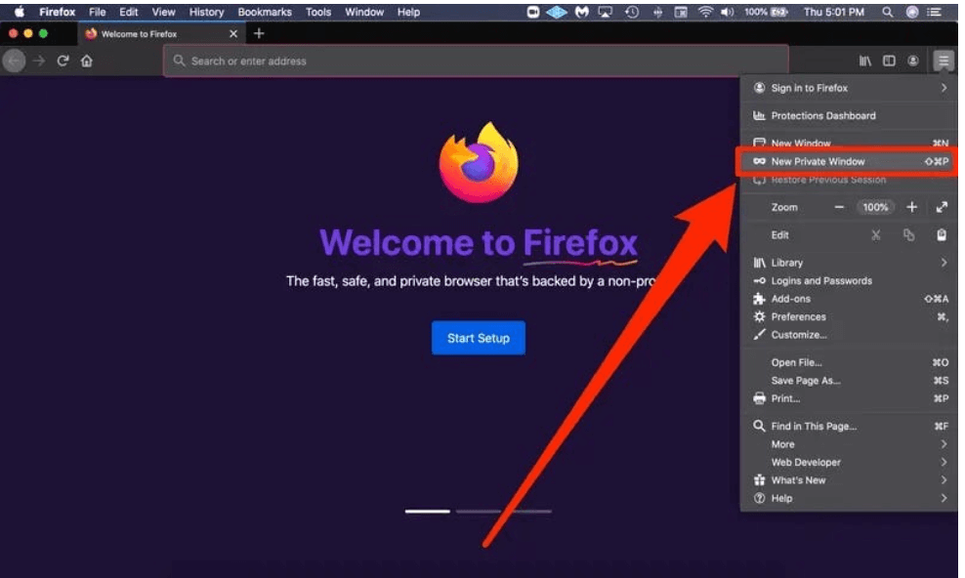
If you are using Microsoft Edge
Select 3 dots icon
- Open Microsoft Edge
- Select the three dots icon in the upper right corner
- Selet New InPrivate Window
